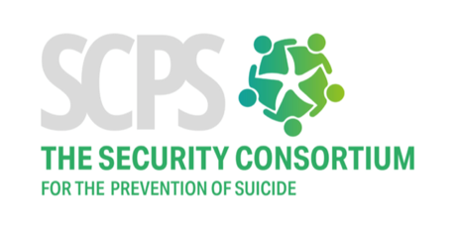

Signed on behalf of:
Ministry of Defence

Signed:

Name:

Position:

Date:

Company name
___________________________________________________
We, the undersigned, commit to support the Security Consortium for the Prevention of suicide and honour its values. We recognise the importance we play in suicide prevention as an organisation providing security services.

Signed on behalf of:

Company Name

Signed:

Name:

Position:

Date:

Add company logo

The SCPS Covenant

An enduring covenant between
The Security Profession
and
The Security Consortium for the Prevention of Suicide (SCPS)

The first duty of the security profession is to keep others safe. Security is a basic need and those vulnerable to suicide are in desperate need of security when they are in a crisis. The very definition of security is that ‘security is the state of being free from danger or threat’. In this understanding, the security profession has a responsibility and key role in suicide prevention.

Joining forces as a Consortium we now have a unique opportunity to use our collective expertise coupled with innovation, to do our part when it comes to suicide prevention, and work together as a community of people dedicated to protecting others.

Our vision is that all people contemplating suicide receive help and support from the security profession to stay alive.
Our mission is to save lives by pooling together security resources, skills and technology to prevent suicide.

Members of the SCPS are key players in security that care about and want to take action on suicide prevention. It is through the members collaborating and working towards shared goals that the vision and mission of the SCPS will be achieved.

Each member holds a piece of the jigsaw. The SCPS is here to assemble the picture.

Demonstrating our Commitment

We will contribute towards the vision of the SCPS, by:

- Developing the collective knowledge of the Consortium by sharing skills and expertise.
- Participating in workshops and trials for the SCPS strategic initiatives.
- Attending SCPS events.
- Implementing relevant SCPS initiatives in my organisation.
- Appointing an SCPS champion or liaison in my organisation.
- Helping generate ideas to develop new ways of tackling suicide prevention.
- Publicising the achievements of the Consortium on our website and social media.

Values of the SCPS

We will endeavour in our business to uphold the key values of the SCPS Covenant which are vital to the success of the vision. The values are:

- Openness and transparency: We will contribute to suicide prevention by sharing professional experiences and knowledge openly and transparently.

- Inclusiveness: We will respect other Consortium members and value each other’s contributions.

- Integrity and Trust: We will work collaboratively with honesty and work with the Consortium in an ethical way.

